Activating your NetOptimizer Installation

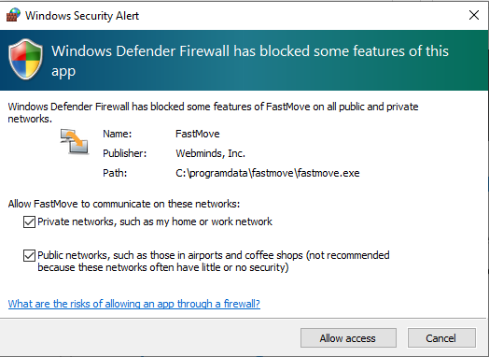

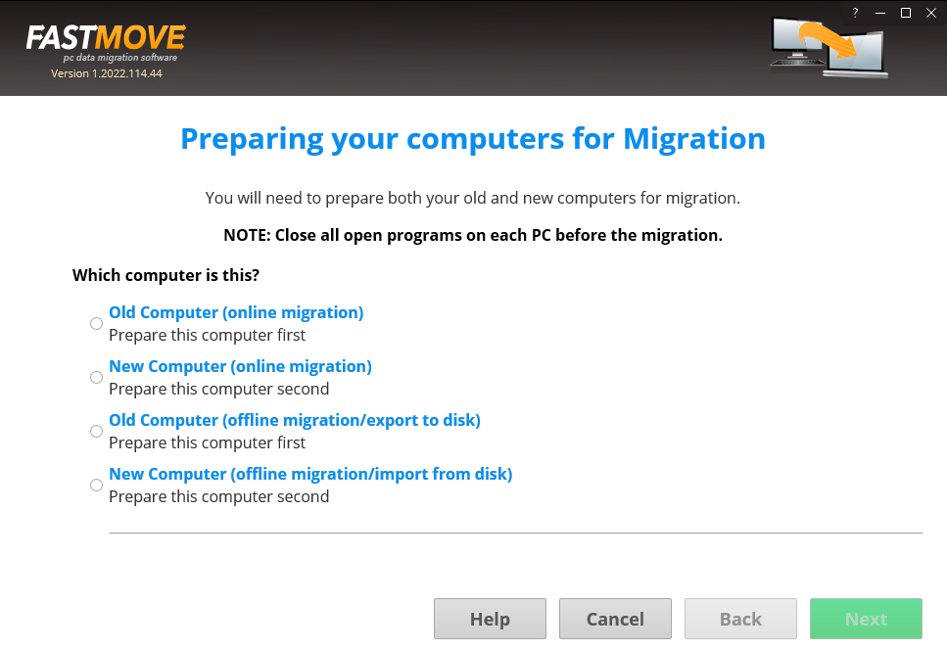

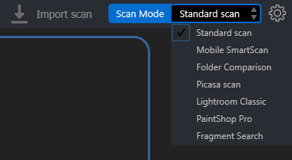

Performing a Standard Scan

Performing a Mobile SmartScan

Performing a Folder Comparison

Performing a Picassa Scan

Performing a Lightroom Classis Scan

Performing a PaintShop Pro Scan

Performing a Fragment Search

* **Step 1 –** This option enables you to –
  + **Start a Scan** in the standard view as depicted in the figure above.
  + **Exit –** This option enables you to close from the EDF application.
* **Step 1 –** This option enables you to change the view of photos as they are displayed on your screen in all the modes on the scan details page. The available sub-options are described as follows –
  + **as Table** – Using this option, you can view the scan details as a list of files as a table. The left table lists the original photos while the right table lists the duplicates.
  + **as Tree** – Using this option, you can view the scan details as a tree; i.e., each of the duplicates are nested under their original photos.
  + **as Multiview** – Using this option, you can view the scan details as thumbnailed list wherein each of the duplicates are listed to the right of their originals. Each thumbnail is also marked if it is Original or if it is a 100% duplicate of the original.
  + **as Theatre** – Using this option, you can view the scan details in such a way the 80% of the screen displays the photo which is centered on the screen. Also, both the original photo thumbnails are listed along with their duplicates in the remaining 20% of the screen at the bottom as a slide list running from left to right.
* **Step 1 –** This option enables you to perform the following actions –
  + **User Guide –** Clicking this option enables you to view this user guide.
  + **Update –** Clicking this option enables you to check if any updates of the EDF application are available.
  + **About –** Clicking this option enables you to view your license information in case you have registered EDF application installation. This option also enables to and purchase a license key depending on the package of your choice. Also, this sub-option enables you to register you application installation and activate it after the system validates your license key successfully.